**Climate suitability modelling: Dracocephalum ruyshiana**

Data, R scripts and output are all at <https://github.com/JamesDMSpeed/Dracocephalum_ruyshiana_climateniche>

Using dataset "Data/Dracocephalum ruyschiana_GBIF_data_edited.xlsx"

Records marked as “Outliers” excluded.

One record as a ‘fossil record excluded.

Remaining records: 4095 (Fig 1)

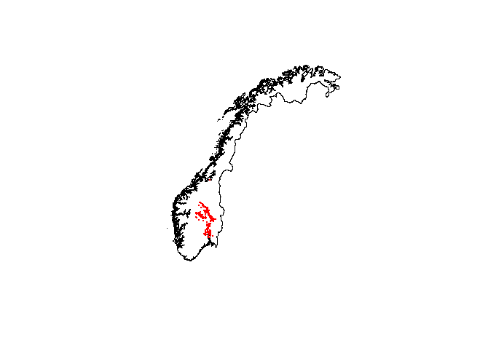

Fig 1 Spatial distribution of occurrence records used in climate suitability model

Three environmental variables selected – mean temperature of the warmest quarter, annual precipitation, precipitation seasonality. These represent the majority of uncorrelated variation in bioclimate variables across Norway. (Speed and Austrheim 2017)

Climate variables downloaded from WorldClim (Fick and Hijmans 2017) at 1 km resolution (Fig 2).



Fig 2. Selected bioclimate variables plotted across study region (Norway). Occurrence points shown.

We used an ensemble model within the sdm package (Naimi and Araújo 2016) in the R environment to produce a weighted average of seven different climate suitability models: Generalized Linear Model (GLM), Generalized Additive Model (GAM), Random Forest (RD), Gradient Boosting Machines (GBM), Mixture Discriminant Analysis (MDA), Flexible Discriminant Analysis (FDA), and Boosted Regression Trees (BRT) were run. Each model was cross validated with five replicate runs. We then averaged the results and predictions across the methods and across the five replicates of each method using a weighted average based upon the model AUC (area under the curve).

Across the replicate models the mean AUC was 0.95 (sd =0.03).

The relative variable importance was highest for mean temperature of the warmest quarter (0.40 ± 0.02) and annual precipitation (0.32 ± 0.02) but lower for precipitation seasonality (0.15± 0.01).

Climate suitability was greatest at warmer and drier regions of Norway (Figure 3a & 3b). Climate suitability was also higher in regions with greater precipitation seasonality (Figure 3c)



Figure 3 Response curves of climate suitability against the three selected bioclimate variables. Mean and standard errors shown with solid and dashed lines respectively.

Model-averaged predictions of climate suitability across Norway are shown in Figure 4. Climate suitability was highest in south-eastern Norway. Suitable, but unoccupied climate can be found around Trysil and in the Trøndelag region along the Glomå. [Edit/expand as you see fit]



Fig. 4. Model averaged climate suitability for Dracocephalum ruyschiana. Occurrence points are shown.

Fick, S. E., and R. J. Hijmans. 2017. WorldClim 2: new 1‐km spatial resolution climate surfaces for global land areas. International Journal of Climatology **37**:4302-4315.

Naimi, B., and M. B. Araújo. 2016. sdm: a reproducible and extensible R platform for species distribution modelling. Ecography **39**:368-375.

Speed, J. D. M., and G. Austrheim. 2017. The importance of herbivore density and management as determinants of the distribution of rare plant species. Biological Conservation **205**:77-84.